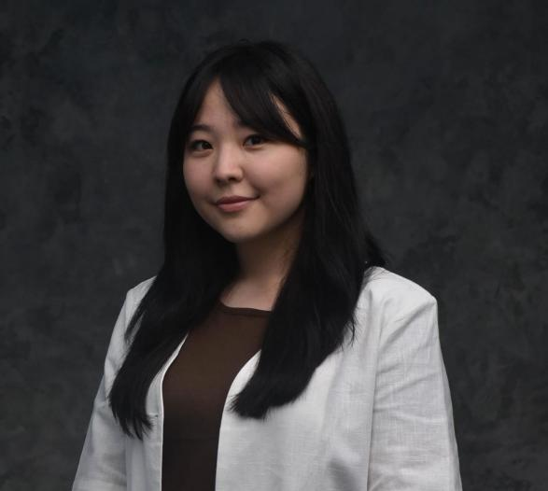

КАЛИЕВА Айсулу Абдыбековна,

№10 орта жалпы білім беретін мектебінің ағылшын тілі пәні мұғалімі.

Алматы облысы, Талғар ауданы

THE FUTURE OF FOOD

|  |  |
| --- | --- |
| **Learning objectives(s)**  **that this lesson is**  **contributing to:** | 8.1.9.1 use imagination to express thoughts, ideas, experiences and feelings;  8.2.3.1 understand with little or no support most of the detail of an argument in extended talk on a wide range of general and curricular topics;  8.4.5.1 deduce meaning from context in short texts and some extended texts on a growing range of familiar general and curricular topics;  8.3.8.1 recount some extended stories and events on a range of general and curricular topics. |
| **Lesson objectives:** | read and understand the main idea from the text; ask and answer the questions about food. |

|  |  |  |  |  |
| --- | --- | --- | --- | --- |
| Planned timings | Teacher activities | Student activities | AfL | Resources |
| **Start**  **5 min** | Teacher greets the class and starts the lesson with dividing the learners into 2 groups of:  1st plants  2nd seeds  Warm-up:  (T-S) (W) Teacher uses “preview” strategy.  Questions:  What do you know about new technologies for growing fruits and vegetables?  Do you know something about genetically modified food?  How do you think what we will eat in the future? | Learners answer the questions and try to guess the theme of the lesson “The future of food”. | - | Smart board  PPP |
| **Middle**  **35 min** | **Task 1** (T-S) (S-S) (G) Teacher uses “graphic organizer” strategy.  The reading material divided between the learners into two groups. All learners from the first group read the first three paragraphs. The second group reads the last two paragraphs.   |  |  | | --- | --- | | **Assessment criteria:** | **Descriptor** | | - identify the meaning of the text about food; | *A learner:*  - reads the text;  - translates and understand the main idea of the text;  - makes a poster and present it. |     **Task 2** (S-S) (P)  Teacher uses “free microphone” strategy to prepare questions on the topic “The future of food”.   |  |  | | --- | --- | | **Assessment criteria:** | **Descriptor** | | - apply their own ideas to talk about feelings;  - retell story about future food. | *A learner:*  - makes a question;  - gives answer for questions.  - asks questions;  - gives microphone for another learner. |   **Task 3** (S-T) (I)  Teacher uses “subtitles” strategy.  At the beginning, learners watch and listen to video without subtitles, and then write down the speaker’s words. After, teacher turns on the subtitles and learners check their work.   |  |  | | --- | --- | | **Assessment criteria** | **Descriptor** | | - recognize given information about food; | *A learner:*  - watches and listens to video without subtitles;  - writes down the speaker’s words;  - watches and listens to video with subtitles;  - checks their work. | | Learners reads the text “What we will eat in the future?”  Learners makes a poster about their food using graphic organizer then retell their part to the other groups using own words.  Learners prepare questions on the topic “The future of food”, and then learners ask questions from each other and answers them.  Learners watch and listen to video without and with subtitles. | “Three stars and one wish”  “smiles”  “ticks and cross” | English Plus  p.101  PPP  Microphone  Smart board  YouTube |
| **End**  **5 min** | **Plenary** (T-S) (S-T) (I)  **5-5-1**  Task One: Write five sentences explaining what you have learnt. Task Two: Turn this into five words explaining what you have learnt. Task Three: Finally, turn this into one word explaining what you have learnt. | Learners write five sentences about what they have learnt during the lesson. Next, they reduce their five sentences to five words. Finally, they reduce their five words to one word. Learners share their key word with the whole class. | Self assessment | Handout materials |